TITLE: INVENTORY MANAGEMENT SYSTEM
Submitted By:
Spoorthi N H
Spoorthy AS

ABSTRACT
The Inventory Management System is designed to analyze and manage raw material inventory efficiently within an organization. The system provides facilities for user registration and login for Admin and Inventory Department personnel. It helps maintain raw material master details, update stock levels, issue materials to the production department, and generate inventory-related reports.
The system allows the Admin to store and manage details of each raw material such as material name, unit, available quantity, ordering cost, inventory carrying cost, and out-of-stock cost. Based on these details, the system supports important inventory analysis techniques such as EOQ (Economic Order Quantity), FOQ (Fixed Order Quantity), and VED (Vital, Essential, Desirable) analysis. These analyses help in better inventory planning, stock control, and decision-making.
The system also supports stock issue transactions and automatically updates the available inventory. In addition, reports such as stock reports, EOQ/FOQ/VED analysis reports, delivery challan, invoice, and goods received note can be generated whenever materials are dispatched or received. The project is implemented using a relational database structure to ensure data consistency, reduced redundancy, and efficient retrieval of inventory information.

ER DIAGRAM
The
The Inventory Management System consists of the following main entities:
1. USER
Stores login details of system users such as Admin and Inventory Department personnel.
Attributes:
- user_id (PK)
- username
- password
- role
2. SUPPLIER
Stores supplier details for raw materials.
Attributes:
- supplier_id (PK)
- supplier_name
- phone
- address
- email
3. RAW_MATERIAL
Stores complete details of each raw material item.
Attributes:
- material_id (PK)
- material_name
- unit
- quantity_available
- ordering_cost
- carrying_cost
- out_of_stock_cost
- supplier_id (FK)
4. STOCK_ISSUE
Stores details of materials issued to the production department.
Attributes:
- issue_id (PK)
- material_id (FK)
- issued_quantity
- issue_date
- issued_to
- issued_by
5. EOQ_ANALYSIS
Stores EOQ calculation details for each raw material.
Attributes:
- eoq_id (PK)
- material_id (FK)
- annual_demand
- ordering_cost
- carrying_cost
- eoq_value
- calculation_date
6. FOQ_ANALYSIS
Stores FOQ calculation details for each raw material.
Attributes:
- foq_id (PK)
- material_id (FK)
- fixed_order_quantity
- calculation_date
7. VED_ANALYSIS
Stores VED classification for each raw material.
Attributes:
- ved_id (PK)
- material_id (FK)
- ved_category
- remarks
- analysis_date
8. REPORT
Stores generated report details.
Attributes:
- report_id (PK)
- report_type
- generated_date
- generated_by
- material_id (FK)
9. DISPATCH
Stores material dispatch details.
Attributes:
- dispatch_id (PK)
- material_id (FK)
- quantity
- dispatch_date
- destination
10. DELIVERY_CHALLAN
Stores delivery challan details.
Attributes:
- challan_id (PK)
- dispatch_id (FK)
- challan_date
- remarks
11. INVOICE
Stores invoice details for dispatched materials.
Attributes:
- invoice_id (PK)
- dispatch_id (FK)
- invoice_date
- amount
12. GOODS_RECEIVED_NOTE
Stores GRN details for received materials.
Attributes:
- grn_id (PK)
- material_id (FK)
- received_quantity
- received_date
- supplier_id (FK)
Relationships
- One supplier can supply many raw materials.
- One raw material can have many stock issue records.
- One raw material can have many EOQ analysis records.
- One raw material can have many FOQ analysis records.
- One raw material can have many VED analysis records.
- One raw material can appear in many reports.
- One dispatch record can generate one delivery challan.
- One dispatch record can generate one invoice.
- One supplier can have many goods received note records.
- One user can generate many reports.
- One user can perform many stock issue transactions.

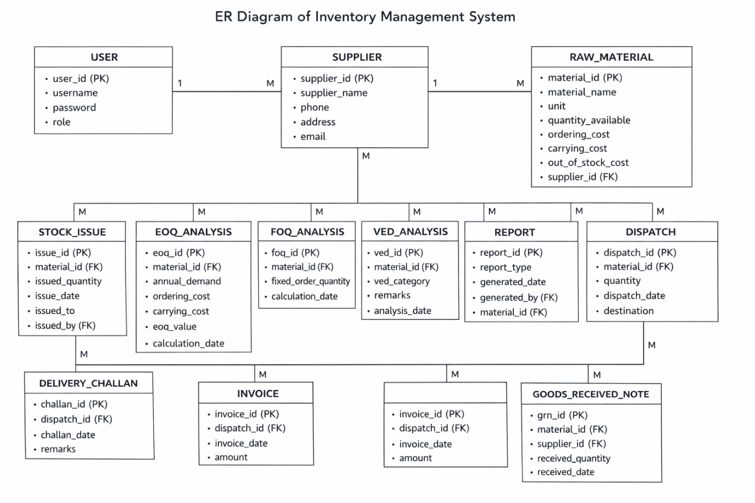

DATABASE DESIGN
The database for the Inventory Management System is designed to store user details, supplier details, raw material details, stock issue transactions, analysis records, dispatch details, and report information. The main tables used in the system are User, Supplier, Raw_Material, Stock_Issue, EOQ_Analysis, FOQ_Analysis, VED_Analysis, Report, Dispatch, Delivery_Challan, Invoice, and Goods_Received_Note.
Table 1: User Table
Field Name | Data Type | Key | Description
user_id | INT | PK | Unique ID of the user
username | VARCHAR(50) |  | Username for login
password | VARCHAR(100) |  | Password of the user
role | VARCHAR(20) |  | Role such as Admin or Inventory Staff

Table 2: SUPPLIER TABLE
Field Name | Data Type | Key | Description
supplier_id | INT | PK | Unique ID of supplier
supplier_name | VARCHAR(100) |  | Name of supplier
phone | VARCHAR(15) |  | Contact number
address | VARCHAR(200) |  | Address of supplier
email | VARCHAR(100) |  | Email of supplier

3. RAW_MATERIAL TABLE
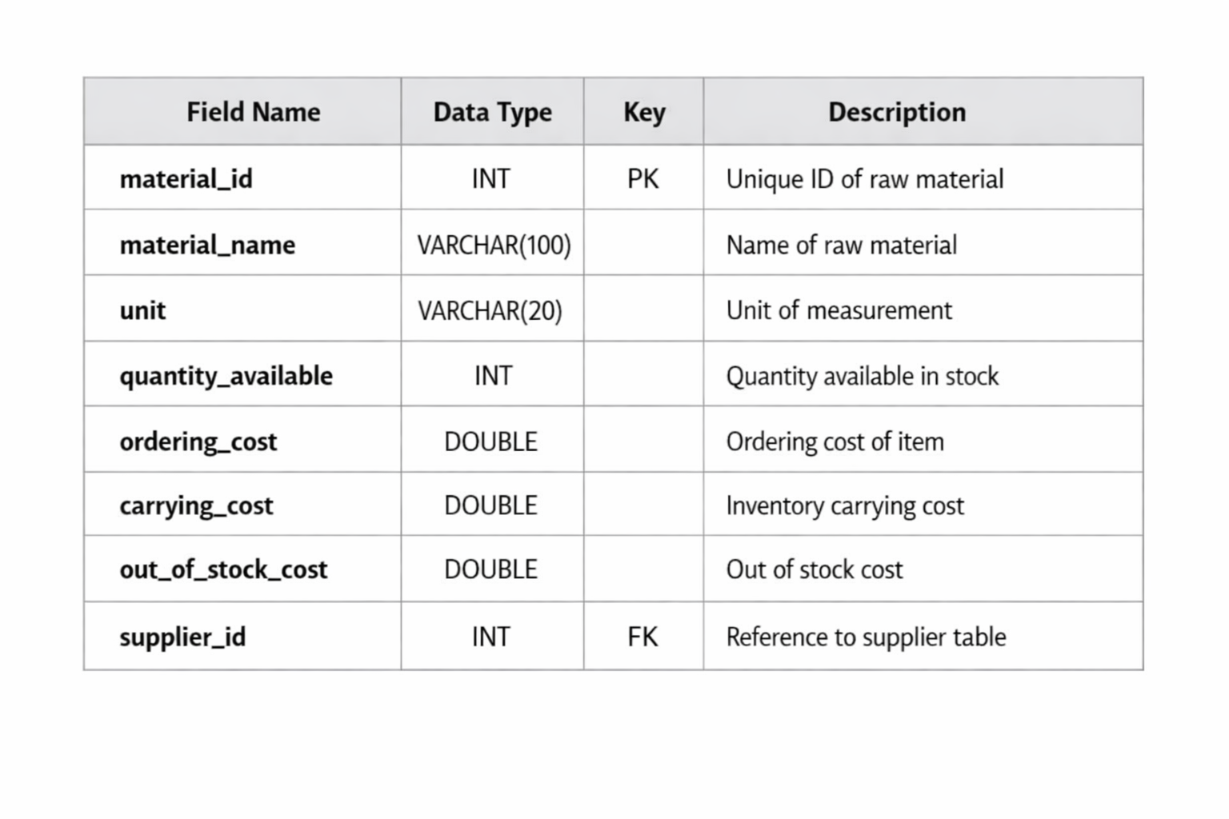

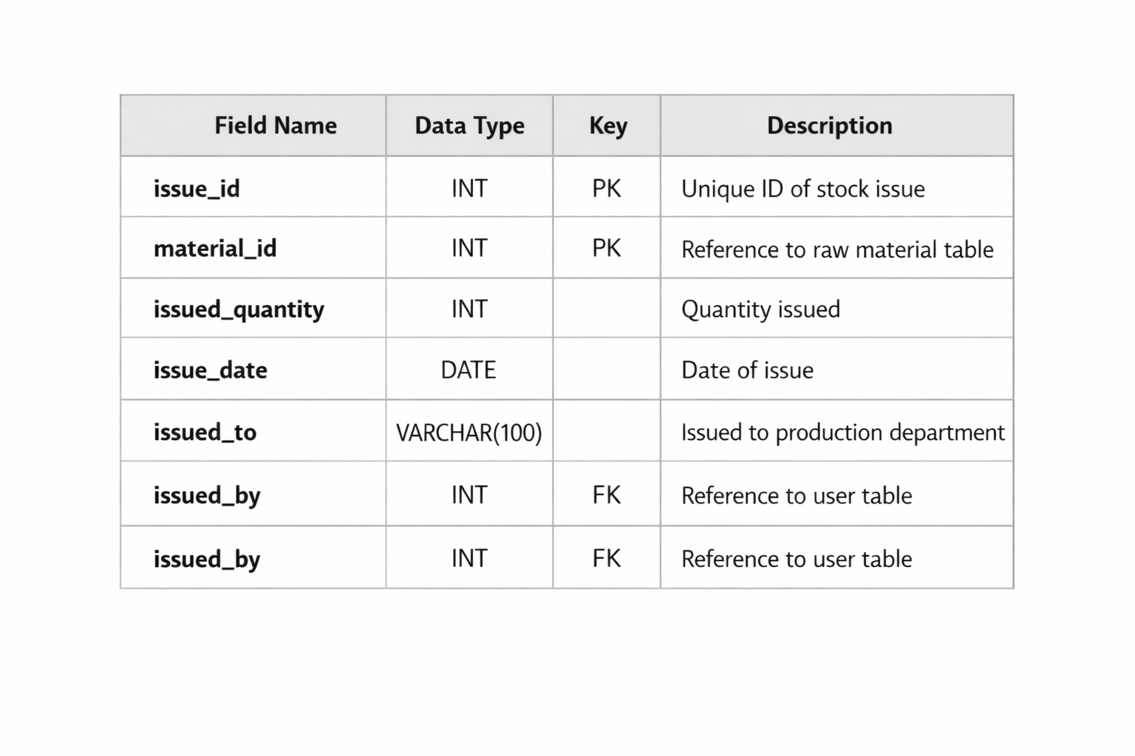
4. STOCK_ISSUE TABLE

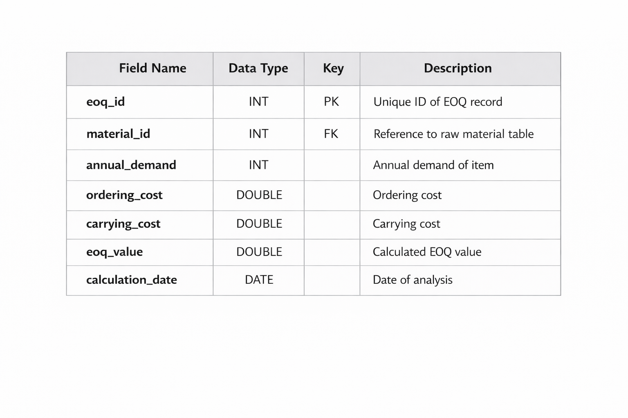
5 . EOQ_ANALYSIS TABLE

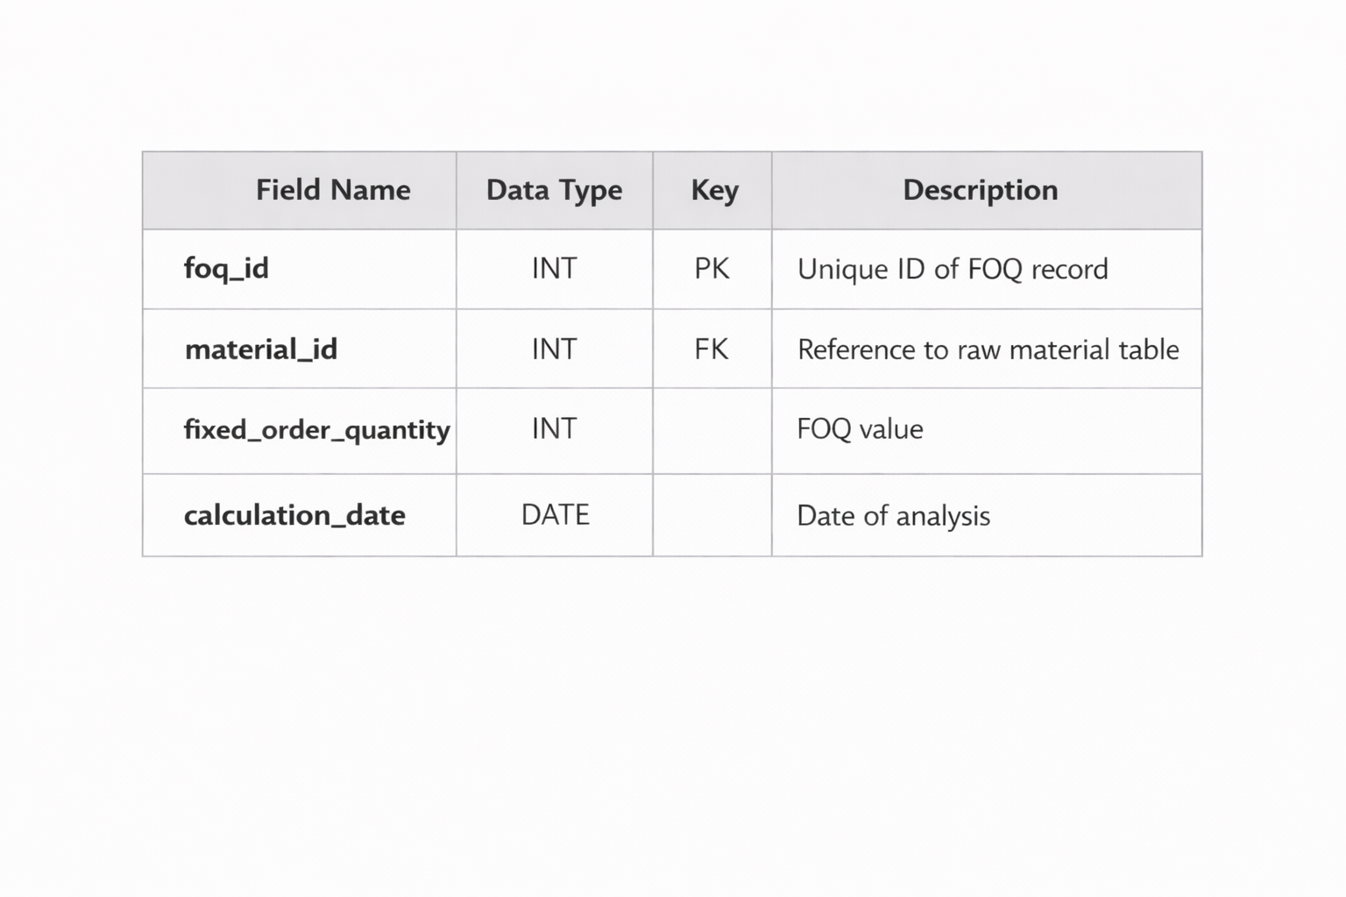
6. FOQ_ANALYSIS TABLE

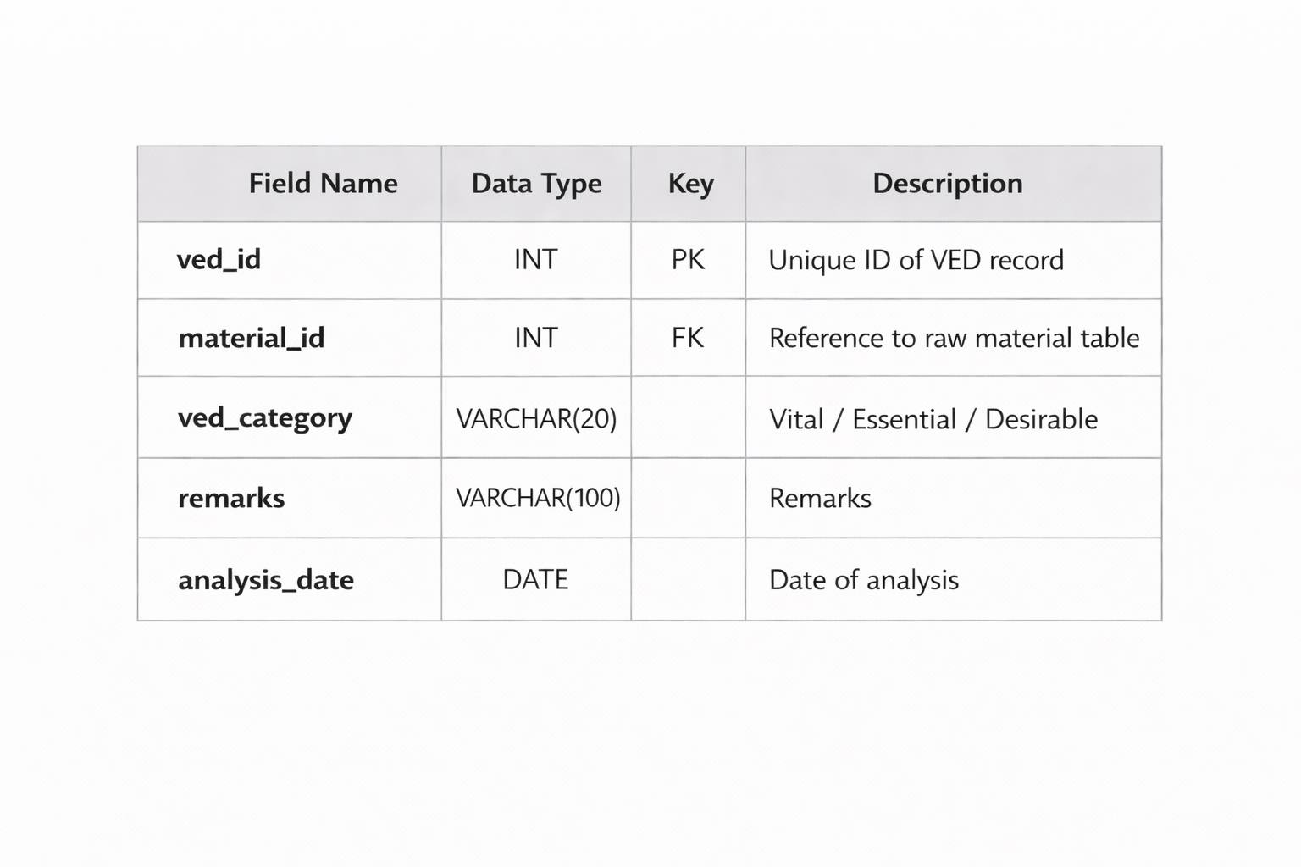
7. VED_ANALYSIS TABLE

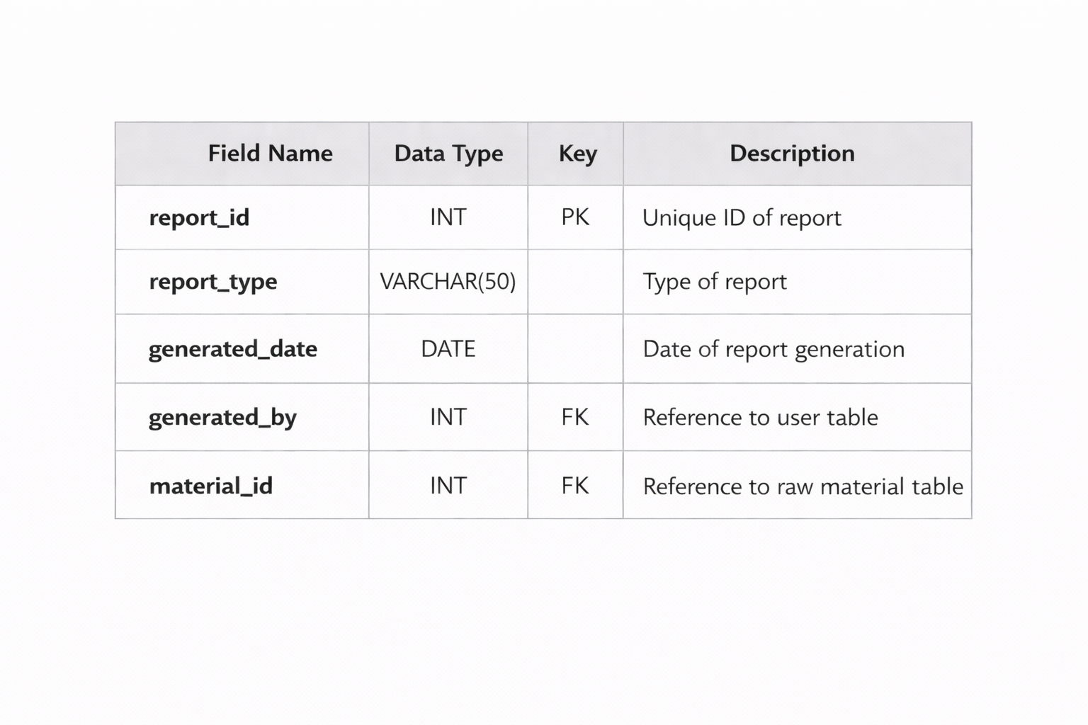
8. REPORT TABLE

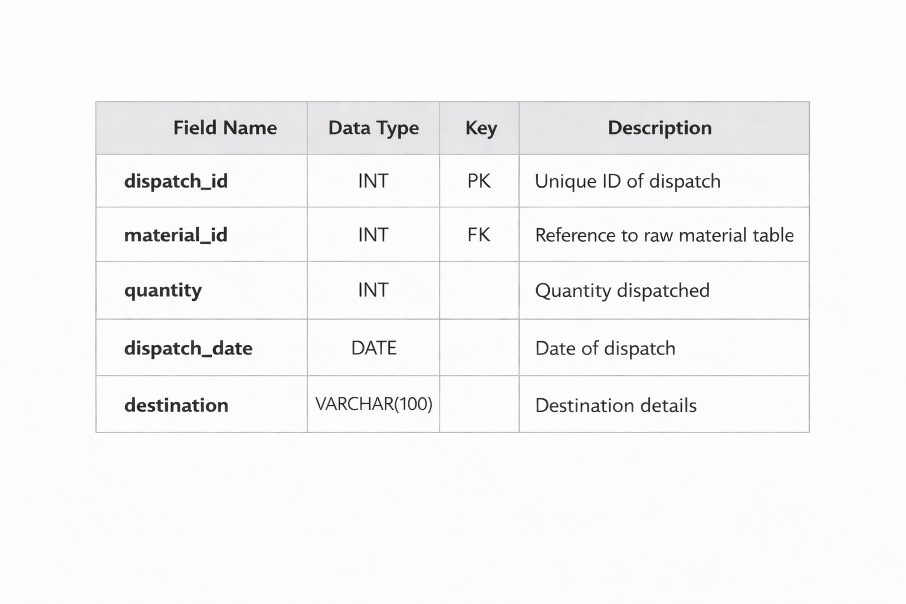
9. DISPATCH TABLE

10. DELIVERY_CHALLAN TABLE
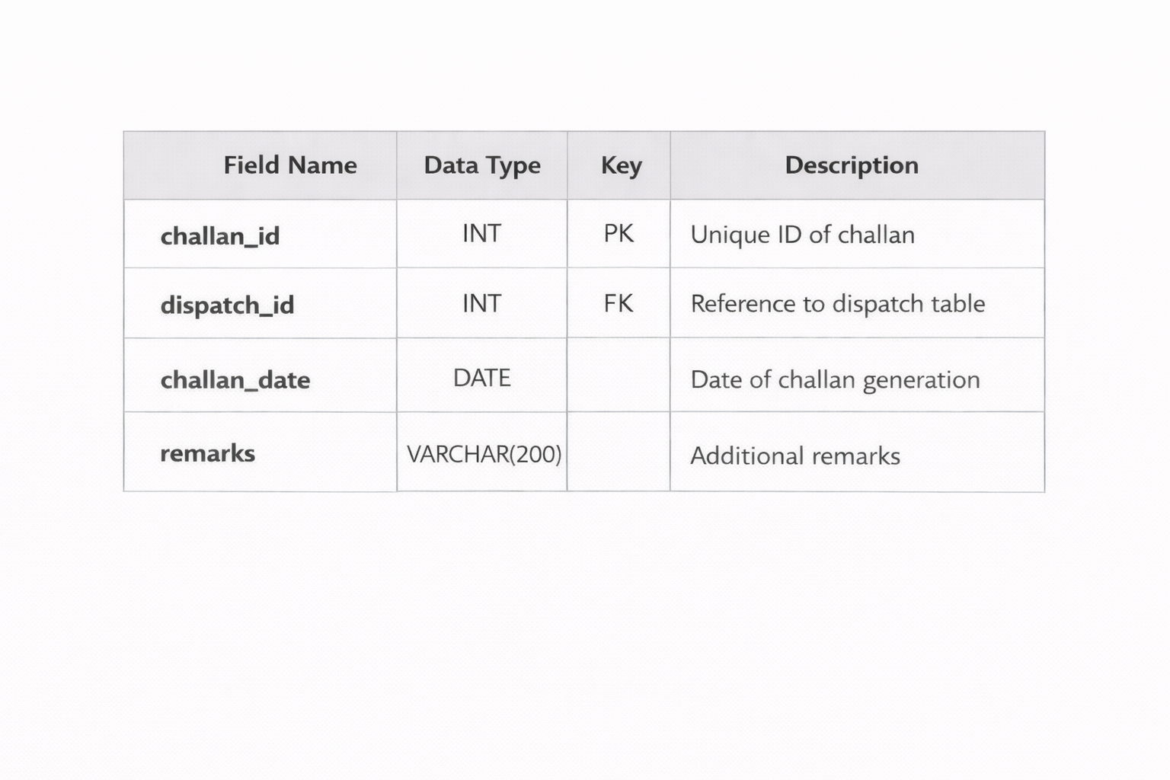

11. INVOICE TABLE

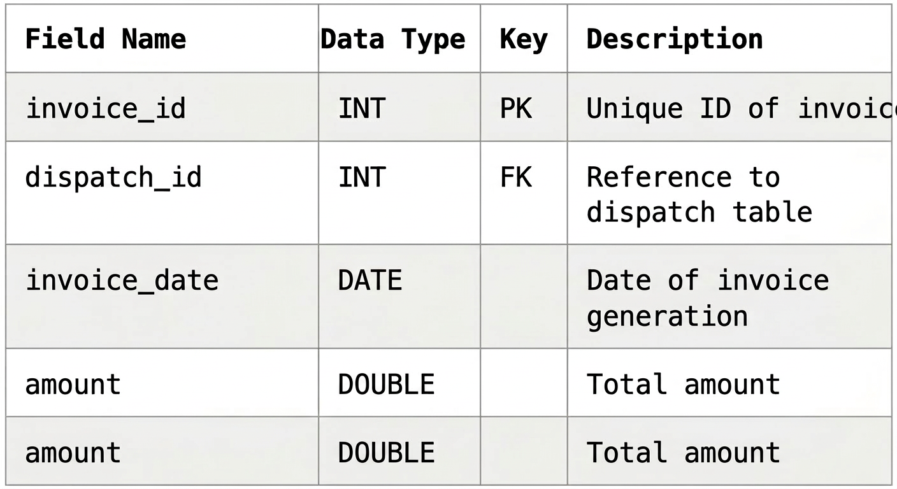
12. GOODS_RECEIVED_NOTE TABLE
